

Sem 2 Examination 2015

Question/answer booklet

MATHEMATICS
Please place your student identification label in this box
SPECIALIST

Section One:
Calculator-Free
Name:

Teacher:

Time allowed for this section
Section One
Reading time before commencing work: 5 minutes
Working time for paper: 50 minutes

Material required/recommended for this paper

To be provided by the supervisor
This question/answer Booklet
Formula sheet

To be provided by the candidate
- Standard items: pens, pencils, pencil sharpener, eraser, correction fluid/tape, ruler, highlighter

- Special items: drawing instruments, templates, notes on two unfolded sheets of A4 paper, and up to three calculators satisfying the conditions set by the Curriculum Council for this course.

Important note to candidates
No other items may be taken into the examination room. It is your responsibility to ensure that you do not have any unauthorised notes or other items of a non-personal nature in the examination room. If you have any unauthorised material with you, hand it to the supervisor before reading any further.

To be provided by the supervisor
Question/answer booklet for Section One, containing a removable formula sheet which may also be used for Section Two.

Structure of this paper

 | Number of questions available | Number of questions to be attempted | Working time (minutes) | Marks available | Percentage of exam
Section One  Calculator—free | 6 | 6 | 50 | 50 | 35
Section Two  Calculator—assumed | 12 | 12 | 100 | 100 | 65
 |  |  |  |  | 100

Instructions to candidates

- The rules for the conduct of Western Australian external examinations are detailed in the
Year 12 Information Handbook 2015. Sitting this examination implies that you agree to abide by these rules.

- Answer the questions according to the following instructions.

Show all your working clearly. Your working should be in sufficient detail to allow your
answers to be checked readily and for marks to be awarded for reasoning. Incorrect answers given without supporting reasoning cannot be allocated any marks. For any question or part question worth more than two marks, valid working or justification is required to receive full marks. If you repeat an answer to any question, ensure that you cancel the answer you do not wish to have marked.

It is recommended that you do not use pencil, except in diagrams.

- You must be careful to confine your responses to the specific questions asked and to follow any instructions that are specific to a particular question.

- Spare pages are included at the end of this booklet. They can be used for planning your responses and/or as additional space if required to continue an answer.
- Planning: If you use the spare pages for planning, indicate this clearly at the top of the page.
- Continuing an answer: If you need to use the space to continue an answer, indicate in the original answer space where the answer is continued, i.e. give the page number. Fill in the number of the question that you are continuing to answer at the top of the page.

- The Formula Sheet is not handed in with your Question/Answer Booklet.

Section One: Calculator–free 35% (50 marks)

This section has six (6) questions. Attempt all questions. Write your answers in the spaces provided.

Spare pages are included at the end of this booklet. They can be used for planning your responses and/or as additional space if required to continue an answer.

- Planning: If you use the spare pages for planning, indicate this clearly at the top of the page.
- Continuing an answer: If you need to use the space to continue an answer, indicate in the original answer space where the answer is continued, i.e. give the page number. Fill in the number of the question(s) that you are continuing to answer at the top of the page.

Working time: 50 minutes

Question 1 (5 marks)

The polynomial 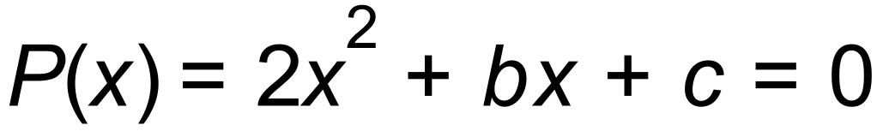 has solutions 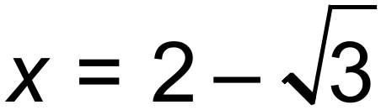 and 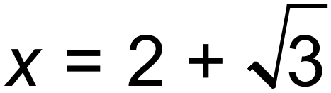 .

(a) Write 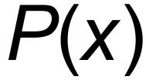 as a multiplication of linear factors. (2 marks)

(b) Hence, or otherwise, determine the value of b and c. (3 marks)

Question 2 (6 marks)

A class of 11 girls and 9 boys must select 2 students to attend a conference.

(a) How many possible combinations of students can be sent to the conference? (2 marks)

Instead the class decided to send four students in total: two boys and two girls.

(b) How many combinations are now possible? (3 marks)

At the conference, the four students from (b) line up for a photograph.

(c) In how many ways can the group line up for the photo? (1 mark)

Question 3 (7 marks)

Consider vectors  and . Determine the value of  if:

(a) vectors a and b are perpendicular. (1 mark)

(b) vectors a and b are parallel. (2 marks)

(c) vectors a and b have the same magnitude. (2 marks)

(d) a + 2b is a unit vector. (2 marks)

Question 4 (12 marks)

(a) A square matrix A is called an involution if and only if 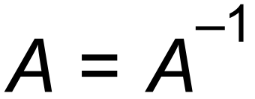.

(i) Given that the matrix 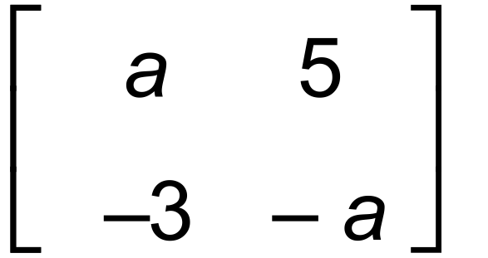 is an involution, determine the value(s) of a.
(3 marks)

(ii) Use one answer from (i) to solve the system of equations below using matrices.
(3 marks)

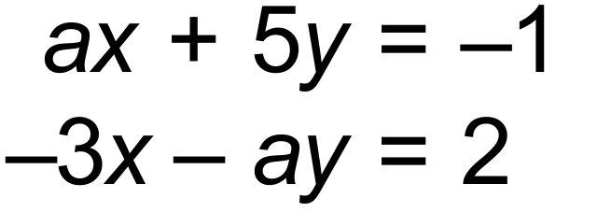

Question 4 (Continued)

(b) Matrix A is such that it satisfies the equation: A² – 2A + 5I = O
where I 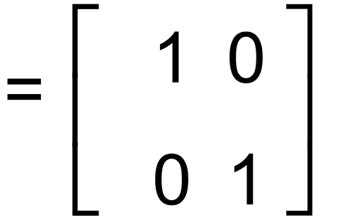 and O 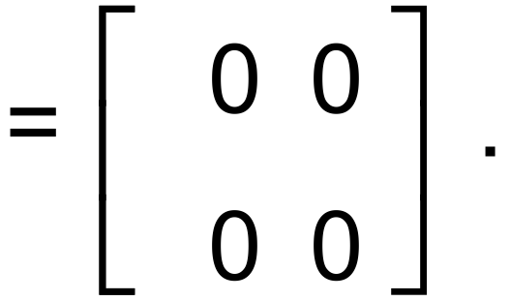

(i) Show that 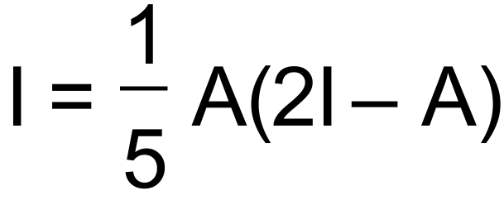. (2 marks)

(ii) Determine the real values and  such that 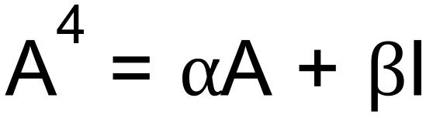. (4 marks)

Question 5 (14 marks)

The graph below shows the function 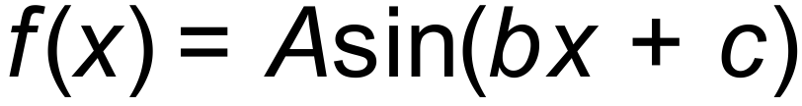 for 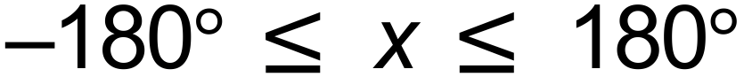.

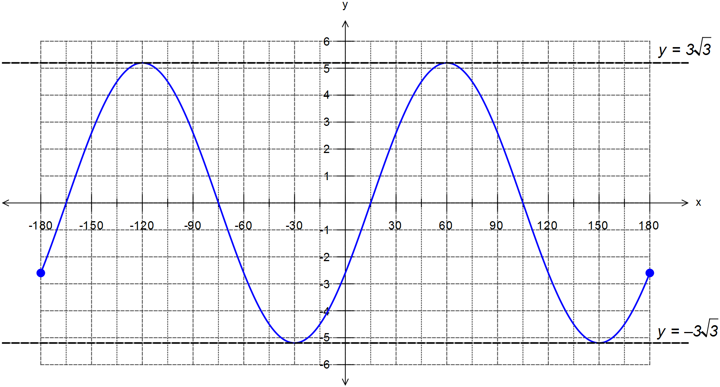

(a) Determine the value of A, b and c. (3 marks)

(b) On the same set of axes above sketch the function 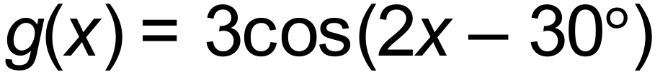 for .

(3 marks)
Question 5 (Continued)

(c) The new function  can be written in the format 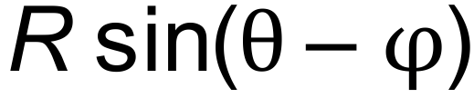, where .
Determine the exact value of  and .
(4 marks)

(d) Hence, or otherwise, solve  for the domain . (4 marks)

Question 6 (6 marks)

Use mathematical induction to prove that for ,

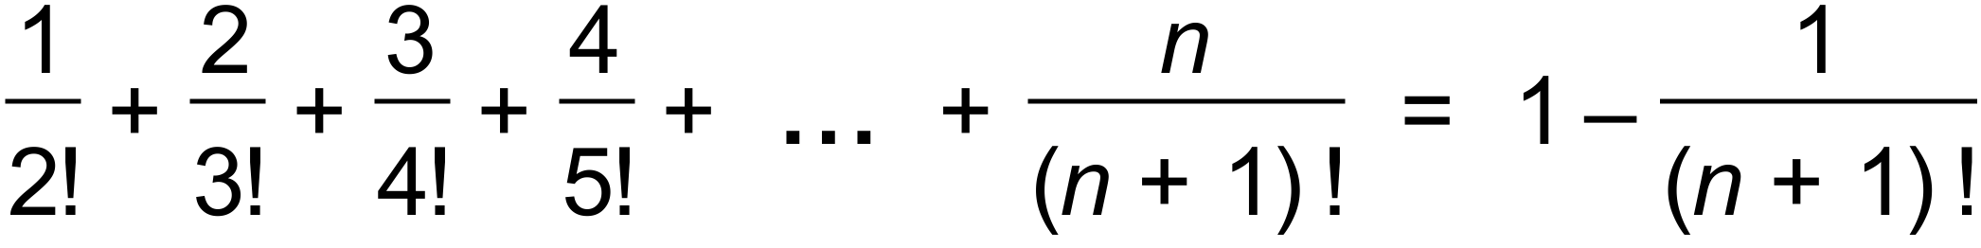

(6 marks)

End of Questions
Additional working space

Question number(s): ……………………

Additional working space

Question number(s): ……………………

